**Exercise 1 : Implementation of Factory Design Pattern**

**How it works :**

1. **Client**  requests an employee type from **EmployeeFactory.**
2. **Factory** check the type and return the corresponding object(“**Android Developer” or “Web Developer”**)
3. **Client** uses the returned objects with help of **Employee interface**,calling the **salary()** method

**Code** :

1. **Logic Code For Factory Design Pattern :**

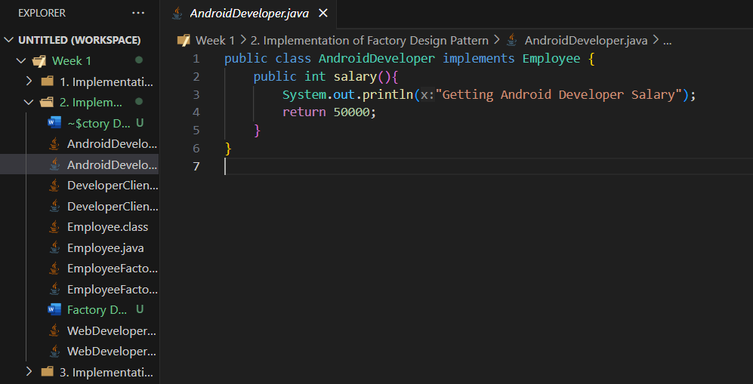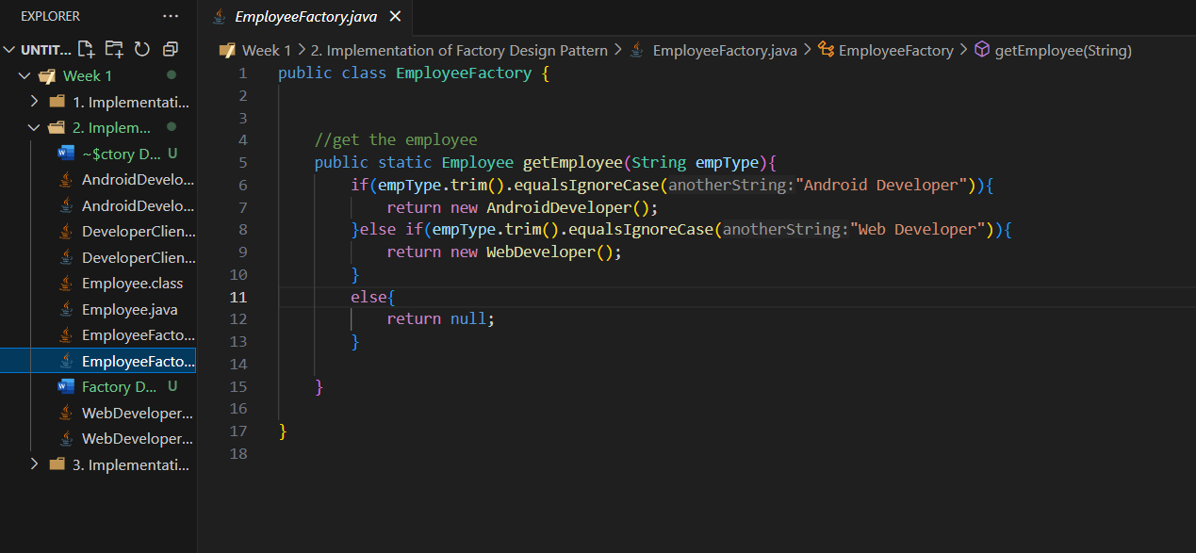

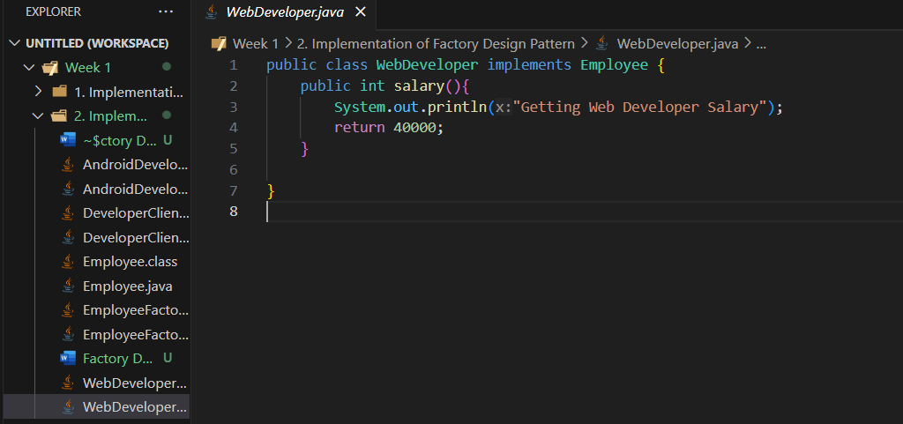

1. **Implementation Code of Factory Design Pattern :** Here, we are checking whether the two created objects share the same parent class.

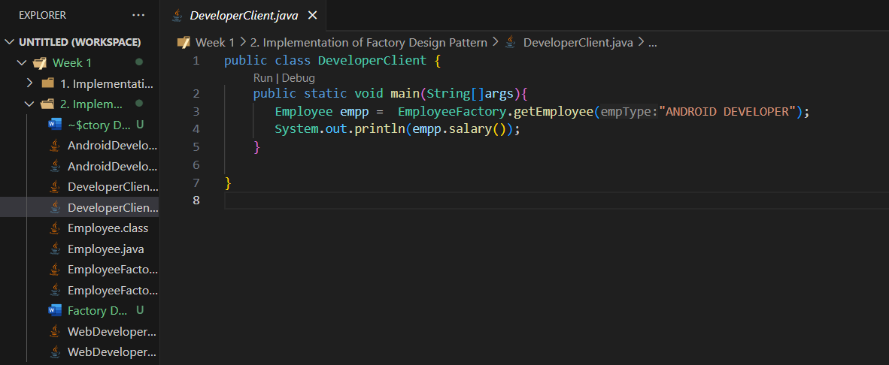

**Output** :